10: 41A and ÄL86%i
Q https://www.icloud.com/ Yahoo ME
All News Videos Images Maps Shopping
Did you mean: https://www.icloud.com/Yahoo
Mail, Weather, Search ws, Finance, Sports &
Videos https://www.yahoo.com/ G Gmail Free, Private & Secure Email I Google Workspace https://www.google.com/gmail/about/ https://accounts.google.com/signup/v2/webcreate account?
ser.com%2Fmail%2F&flowName=GlifWebSignin&flo Signup G Create your Google Account) G Create your Google Account https://accounts.google.com/signup/v2?servicemail&continue.com%2Fmail%2F&flowName GlifWebSignin&flowEntry-Signup G Gmail: Free, Private & Secure Email I Google Workspace https://www.google.com/gmail/about/# G Google. https://www.google.com/?
b Bing https://www.bing.com/ W Wikipedia https://www.wikipedia.org/ Facebook-Log in or Sign Up https://www.facebook.com/Twitter. It's what's happening/Twitter https://twitter.com/ In Linkedin: Log In or Sign Up https://www.linkedin.com/ b hotel tv show - Bing b hotel-Bing https://www.bing.com/search? q=hotel+tv+show&fllters=dtbk % ff-836f-
https://www.bing.com/search?
q=hotel&go=Search&qs=n&form_sc-8-
Apple https://www.apple.com/ Tuesday, August
31, 2021 4 items Otravelocity hotel at
DuckDuckGo Otravelocity hotel at DuckDuckGo Otravelocity hotel at DuckDuckGo Tripadvisor:
Read Reviews, Compare Prices & Book Sunday,
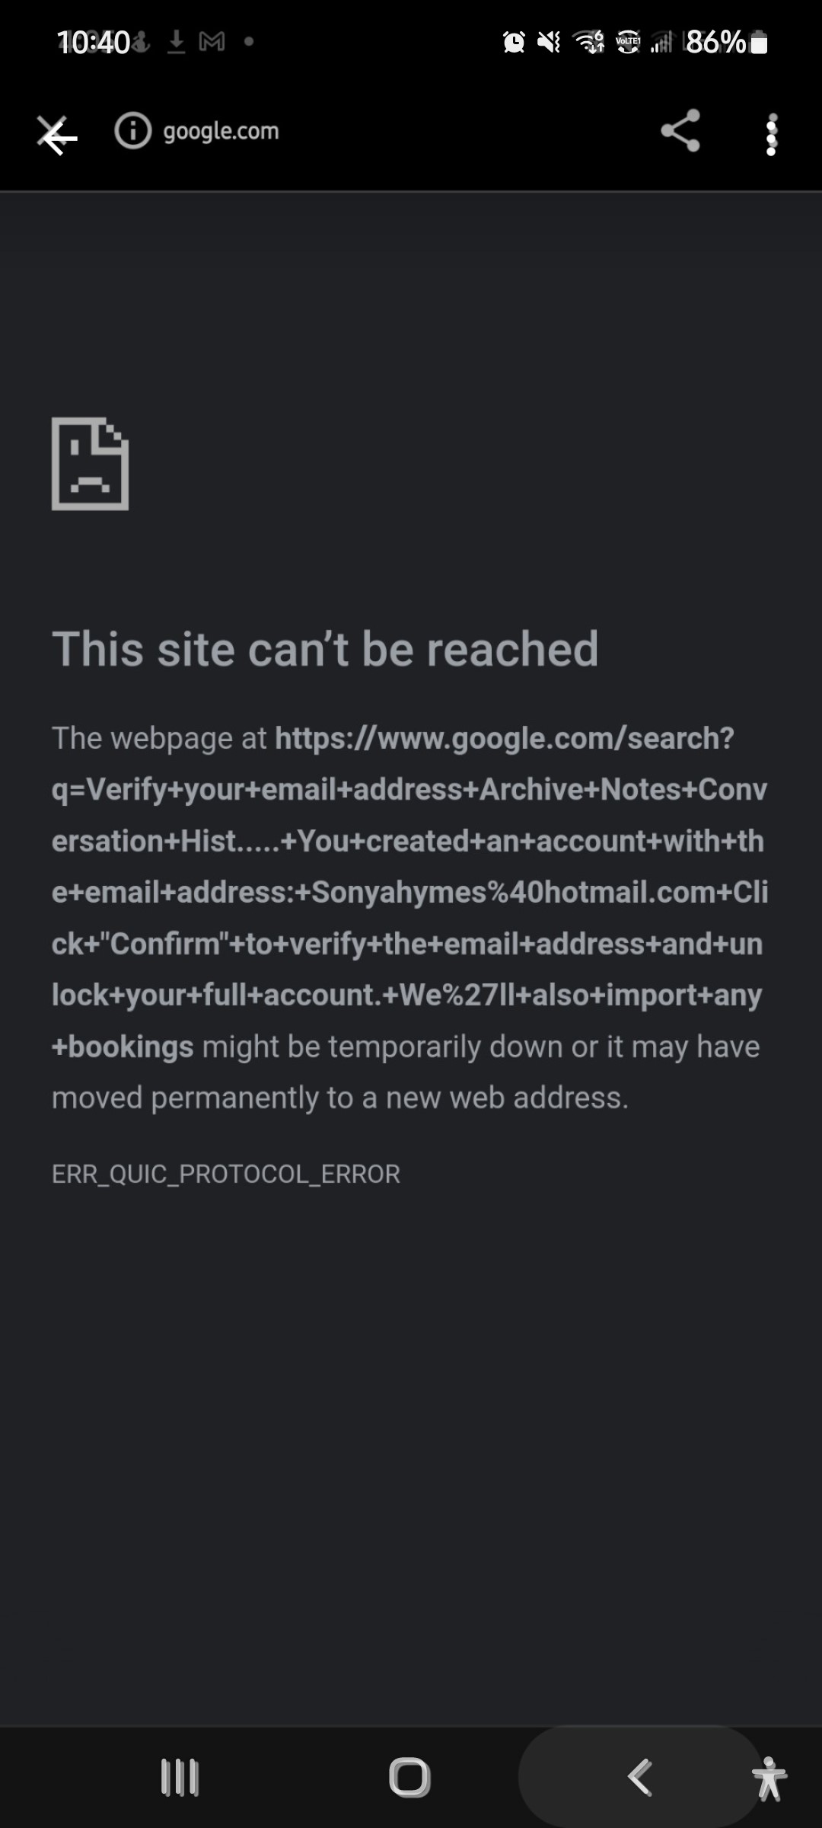
verify your email address archive notes conversation hist..... you
 | created an account with the email
Or | address: sonyahymes@hotmail.com click "confirm" to verify the email address and unlock your full account. we'll also import any bookings  folders one more click to confirm your account. inbox 10585 booking booking.com  <noreply@booking.com> fn 6/4/2021 1 pm junk email 44 to:  sonyahymes@hotmail.com drafts 8 booking.com sent items deleted items verify your email address archive notes conversation hist you created an account with the email | x
Or | address: sonyahymes@hotmail.com click "confirm" to verify the email | x
address and unlock your full account. we'll also import any bookings you've made with that address. confirm new folder groups copyright 0 1996-2021 booking.com. all rights reserved. this email was sent by booking.com, herengracht 597, 1017 ce amsterdam, netherlands privacy and cookies customer service
reservations - google search hotel reservations through costco at

check-in=2021-09-04 &q-check-out2021-09-05 b&q rooms=l &q-room-O-
Or | adults-I &q-room-O-chiIdren=O tell us what you were trying to get to on this page -+ were tell us what you were trying to get to | x
Or | on this page -+ were you looking for a hotel? try searching again here: enter  3:27 myactivity.google.com my | x
Or | activity visited costco travel: home 12:37 am details  us js travelocity.com hotelco... eleton.js js tripadvisor.com hotel- | x
Or | co... eleton.js > travelocity.com hotelco... eleton.js travelocity.com hotelco... eleton.js tripadvisor.com | x
Or | x google analytics x  check-in=2021-09-04&q-check-out2021-09-05&q rooms-I &q-room-O- | x
Or | adults-I &q-room-O-chiIdren=O tell us what you were trying to get to on this | x
page -+ were
3:27 myactivity.google.com my activity visited costco travel: home 12:37 am details february 4 search visited costco travel: home 10:44 pm details x sep 11, 2020 search visited costco travel: home 9:16 am details
folders one more click to confirm your account. inbox 10585 booking booking.com
<noreply@booking.com> fn 6/4/2021
1 .•OO pm junk email 44 to:
sonyahymes@hotmail.com drafts 8 booking.com sent items deleted items verify your email address archive notes conversation hist you created an account with the email
O address: sonyahymes@hotmail.com x click "confirm" to verify the email address and unlock your full account. we'll also import any bookings you've made with that address. confirm new folder groups copyright 0 1996-2021 booking.com. all rights reserved. this email was sent by booking.com, herengracht 597, 1017 ce amsterdam, netherlands privacy and cookies customer service
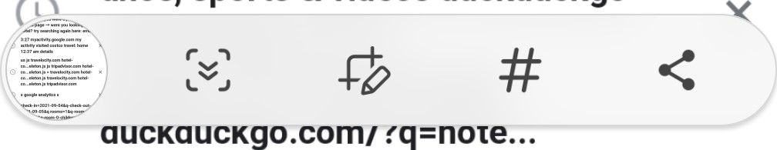
reservations - google search hotel reservations through costco at duckduckgo hotel reservations at duckduckgo hotel reservations through costco at duckduckgo hotel reservations at duckduckgo hotel reservations - google search (no title) ance, sports & videos duckduckgo
(0
10:35 "Ill
x https://myactivity.google.co...
Q Guest names
Filter by date & product 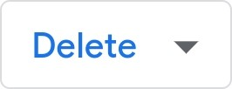
March 9
Search
12:48 PM
Visited diff --git a/models/distilbert-basewit/vocab t
Search • Details
Visited mt-dnn
Search • Details
Visited Welcome, Intel Connected Care AZ Members - AZ C...
Search • Details
March 6

10:35 x https://myactivity.google.co...
Item details
S Search
Visited the and of a to in i it with that you at this on from he my or we but as ...
Details
March 2 at 5:59 PM
Search
Unknown Device
Why this activity?
This activity was saved to your Google Account because your Web & App Activity setting was on while using Search.
Manage
O If you use a shared device or sign in with multiple accounts, activity from another account may appear here. Learn more
5:05 .1 73%.
O wam powder, clear dupe and
All Images Videos News Maps Shopping
US (English) Safe search: moderate Any tirr
https://answersmeta.com > 135409-does-fabric-mod„.
Question Does Fabric Mod Podge dry clear? How long do you ..
The Mod Podge matte product will dry clear with a matte finish, meaning it is not shiny. The Mod Podge Gloss, however, will add a layer of sheen to your project. It feels dry within an hour, but I wouldn't hang up a project or use it until it's been dry for 24 hours. For Hard Coat, the recommended dry time is 72 hours.

https://www.tradeindia.com > products > fast-dry-cle... Fast Dry Clear Coats at Best Price in Guangdong, Guangdong ...
We have gained proficiency in exporting, supplying and trading of Fast Dry Clear Coats with the following details: High Solid Premium Clear Coat, with properties of high build, excellent gloss, high hardness, excellent weather resistance. Substrates : 1K Solid Colors, Metallic Colors

No more results found for wam powder, clear dupe and the 1/3 proportions and spre un brush or fur coats over the modet ettng och coat dry ay with #20 W, Afer you the est color to be Afroday or wet and the entire mode sada nooth sh Spray on your firal cots of color. Follow when dry with a ve coats of clear dope, spe, thewing the last two chats until they are very mode dry for about three wek Theuning reguar ato rubbing compound, rub the model by hand or with a buffer. Put on your
12:1 1
Keport VIVIUA / oopyngnt
DOWNLOAD FILE
Citation preview
http://ebook.hyosung.com/include/catalistt.jsp?
catimage=&Dir=&sort= https://www.winiadimchae.com/ebook/access/ecatalog catimage=&start=&callmode=normal&eclang=ko&Dir=17 https://hdc-dvp.com/e-book/access/ecatalogt.jsp?
catimage=&start=&callmode=normal&eclang=&Dir=60&a https://refer.kumc.or.kr/anam/contents/consulting/boar( cat_no=55 https://order.noodlelovers.com/ebook/access/ecatalogt.jsp?
catimage=&start=&callmode=normal&eclang=ko&Dir=4& https://www.sejonghakdang.org/ebook/access/ecatalogt.jsp?
catimage=&start=&callmode=admin&eclang=&Dir=376& http://gbtp.or.kr/e-book/access/ecatalogt.jsp?
catimage=&start=&callmode=normal&eclang=&Dir=84&a http://pdf.krx.co.kr/ebook_new/access/ecatalogt.jsp?
catimage=&start=&eclang=ko&Dir=23&acmode=disable http://www.bok.or.kr/ebook/access/ecatalogt.jsp?
catimage=&start=&callmode=&eclang=&Dir=8&acmode= http://www.tta.or.kr/ebook/access/ecatalogt.jsp?
catimage=l http://movie.guri.go.kr:9443/ebook/access/ecatalogt.jsp?
catimage=2&start=&callmode=admin&eclang=&Dir=11 http://ebook.jje.go.kr/ebook/access/ecatalogt.jsp?
catimage=&start=&callmode=normal&eclang=ko&Dir=17 https://www.airportal.go.kr/ebook/access/ecatalogt.jsp?
catimage=&start=&callmode=normal&eclang=ko&Dir=52
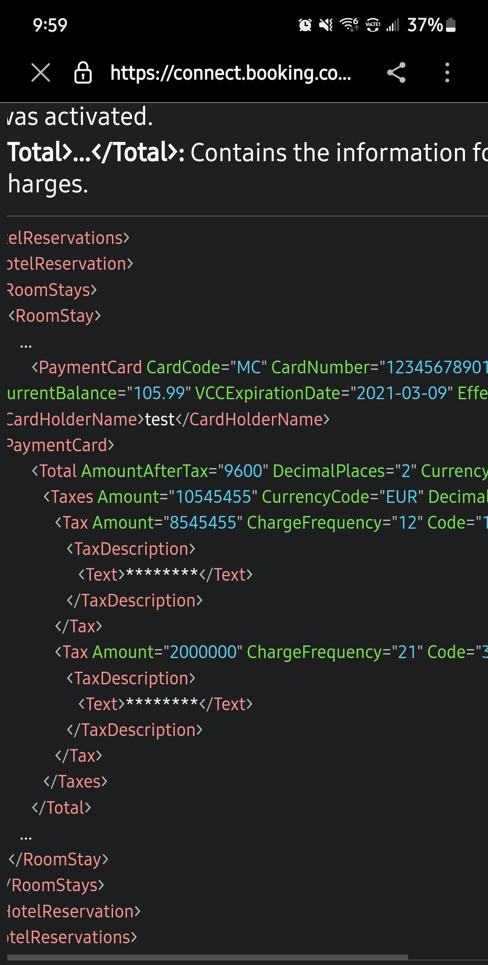
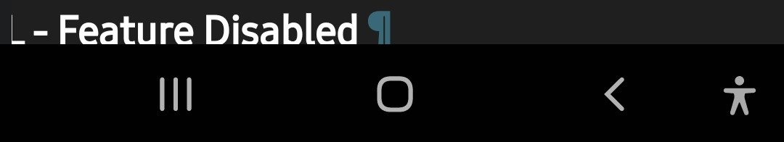
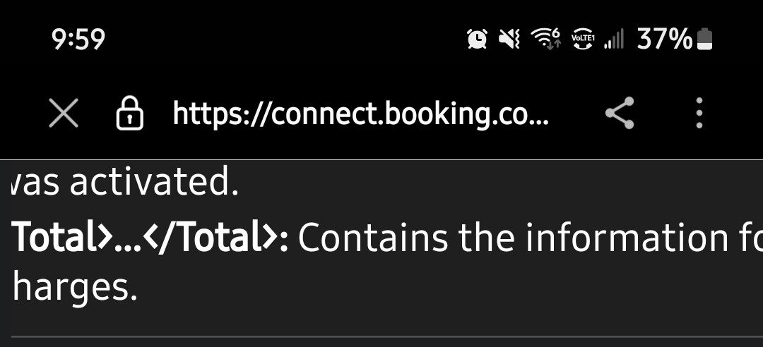
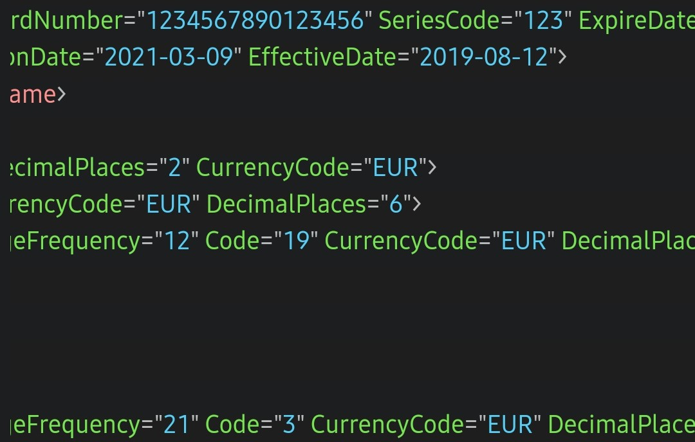
8:08
SPA ... 0 4.6 170 eviews Currency Ca lator Mobile x Key Digital Chec -In fnglis!l pco Ing eservat•v n Please note - A daily resort fee I be added to the room rate and includes use of bicycles, driving range, Internet and more. Please note - Fully vaccinated guests are no longer required to wear face coverings or social distance, unless required by local law. Your receipt for hotel stays may be automatically sent to the email address associated with your reservation. If you prefer, you may request a paper copy at the front desk when you
Details Today at 7:46 AM
Search
Loo Unknown Device
Conv Share
Copy Share
or
SPA ... 0 4.6 1705 Reviews Currency Calculator Mobile
Key Digital Check-In Upcoming Reservation Please note - A daily resort fee of USD 40 plus tax will be added to the room rate and includes use of bicycles, driving range, Internet and more. Please note - Fully vaccinated guests are no longer required to wear face coverings or social distance, unless required by local law. Your receipt for hotel stays may be automatically sent to the email address associated with your reservation. If you prefer, you may request a paper copy at the front desk when you

Details
Today at 7:46 AM
Search
Loo Unknown Device
Conv Share
Copy Share
7:53 .11
Search
8:46 PM
Visited vocab.txt ? vinai/bertweet-covid 19base-uncased ...
Search . Details
Visited vocab.txt.
CARDIFF cardiffnlp/bertweet-base-stance-
NLP
subscription...
Search . Details
English (US)

Jul 25, 2021 - I'm not receiving confirmation emails or password reset emails (checked spam) and am looking to change the date of a booking to next week .
Missing: Fri 6/4/2021 1 44 Son ah mes @ hotmail: + Drafts 8 Deleted Items Verify Archive Notes B https://www.booking.com > content
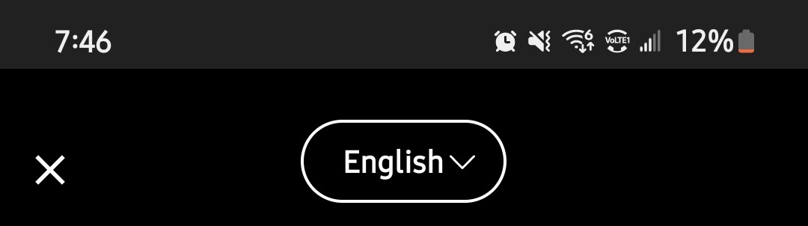
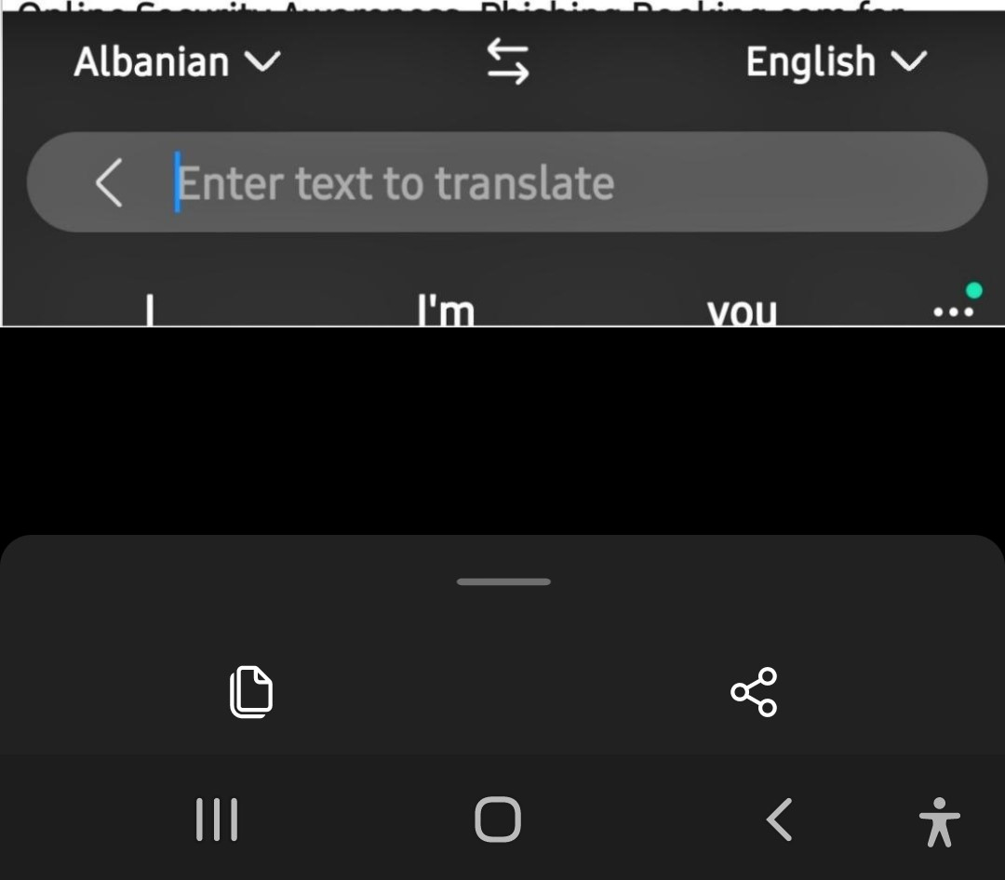
Privacy & cookie statement. Booking.com
Oct 27, 2021 - "Trip Reservation" refers to the order, purchase, payment, booking, or reservation of a Trip. What kind of personal data does Booking.com ...
Missing: Fri 6/4/2021 1:00 PM 44
hotmail: + Drafts 8 Archive Conversation https://partner.booking.com > help
7:42 .11
Jul 25, 2021 - I'm not receiving confirmation emails or password reset emails (checked spam) and am looking to change the date of a booking to next week ...
Missing: Fri 6/4/2021 1 44 Sonyahymes @ hotmail:
wwwwwwwwww + Drafts 8 Deleted Items Verify Archive Notes B https://www.booking.com > content
Privacy & cookie statement. Booking.com
Oct 27, 2021 - "Trip Reservation" refers to the order, purchase, payment, booking, or reservation of a Trip. What kind of personal data does Booking.com ...
Missing: 'noreply@ Fri 6/4/2021 1:00 PM 44
Sonyahymes@ hotmail: + Drafts 8 Archive Conversation https://partner.booking.com > help
Copy Share
or
6:54 A "Ill
generation Web
Google Lens
Maps

N 44
O Visited 48373359...
Alexa •Competfljve Analysis. Morketng tax- rttP4a
Website
and Troffec |  | Fast cry  Guanodc
the site 00 | so.rr«_
•note
user 'st com
dupe •no http•• tom I. it. ot rur
DA PA Checker - Al Moz rnetncs 2 0 ul>döte
2020. Mæestc. Age _ or wot aru on your ve coats chats unti
Translate Text Search Shopping Places
Visual matches
dit Offer: Rewards card [Available)
Sales • CredtCards • RewardsCard PegaCRM.Art1tacts:01-01-0 i
Details Engagement policy Treatments Flow Test A Yell

